|  |  |  |  |
| --- | --- | --- | --- |
| ROUTES | Qty | MORNING @ 07:00 | EVENING 19:00 @ CHURCH |
|  |  | **Driver (bodies)** | **Driver (bodies)** |
| Blue | 20 | Fackler (2+) ? | Fackler (2+) ? |
| Bryan | 4 |  |  |
| G 1-S | 21 | Hays (2) | Hays (2) |
| G 2-N | 17 | Mays/Cabrera (4) | Mays/Cabrera (4) |
| Red | 20 | McLaughlin (4) | McLaughlin (4) |
| Yellow | 24 | Fajt (2) | Fajt (2) |

* David Fackler’s Cell: 979-255-9469

Contents

BLUE ROUTE 2

Bryan (Brown) 3

G1 -S – Dark Green Circles 4

G2 – N – Green Squares 5

RED ROUTE 7

GBL (St Thomas, Hillel, and Grace Bible @ 700 Anderson) 8

# BLUE ROUTE

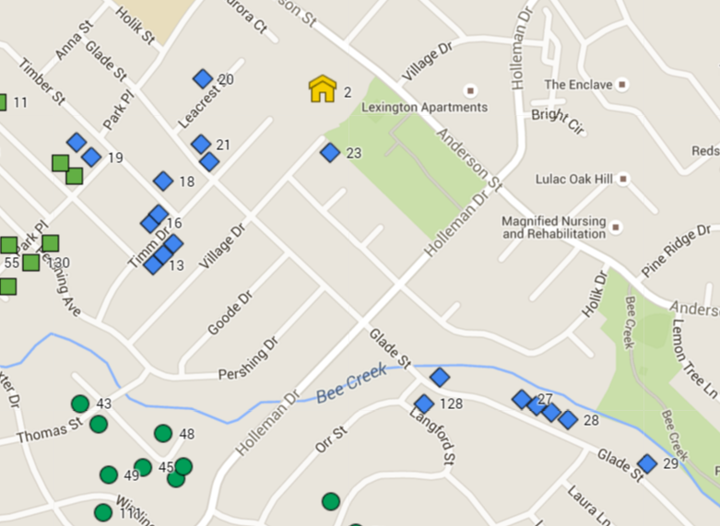

# Bryan (Brown)

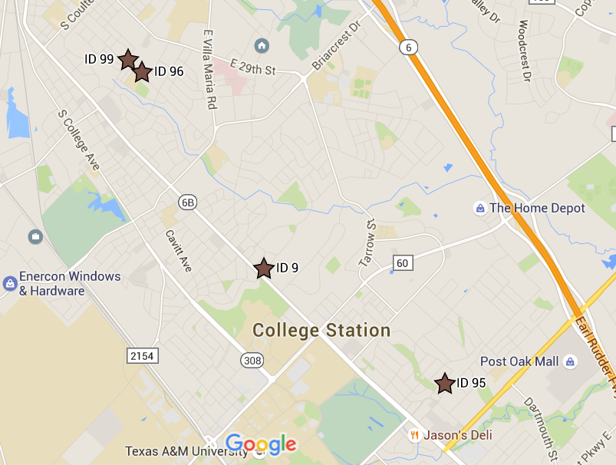

# G1 -S – Dark Green Circles

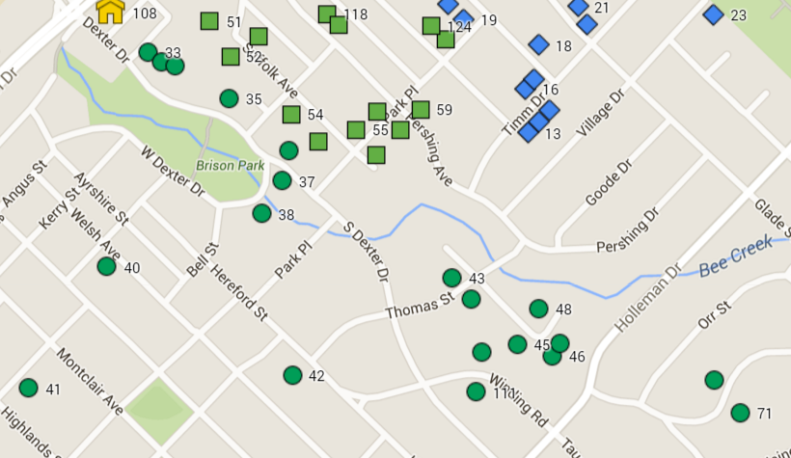

# G2 – N – Green Squares

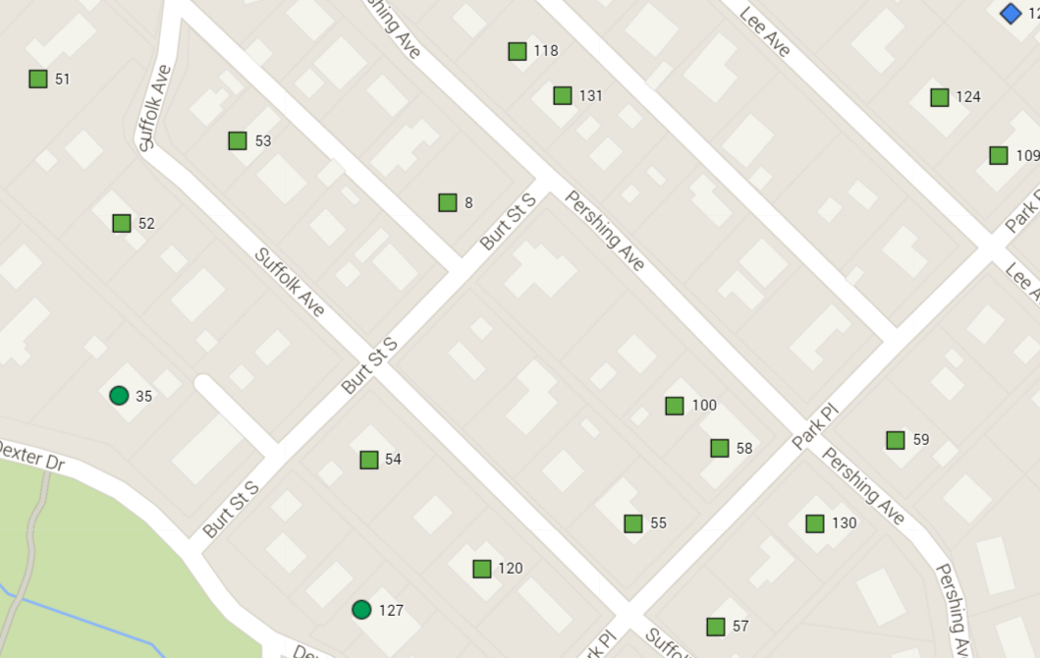

# RED ROUTE

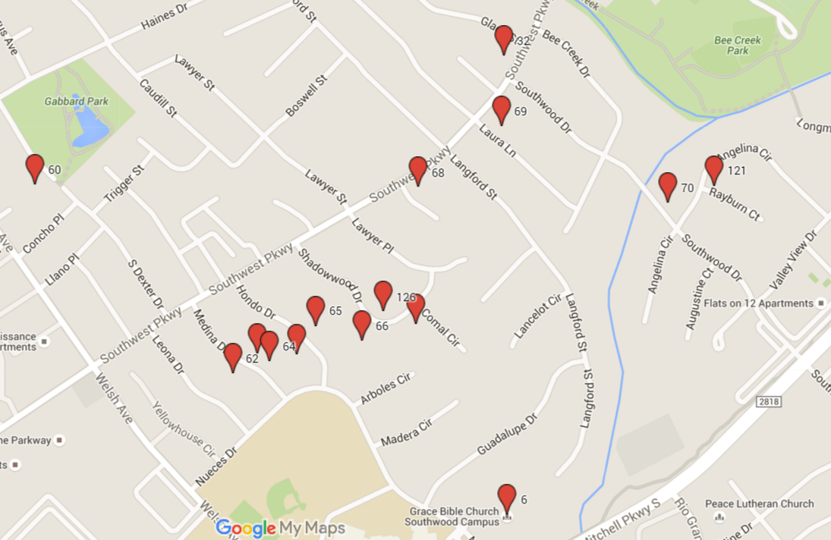

# GBL (St Thomas, Hillel, and Grace Bible @ 700 Anderson)

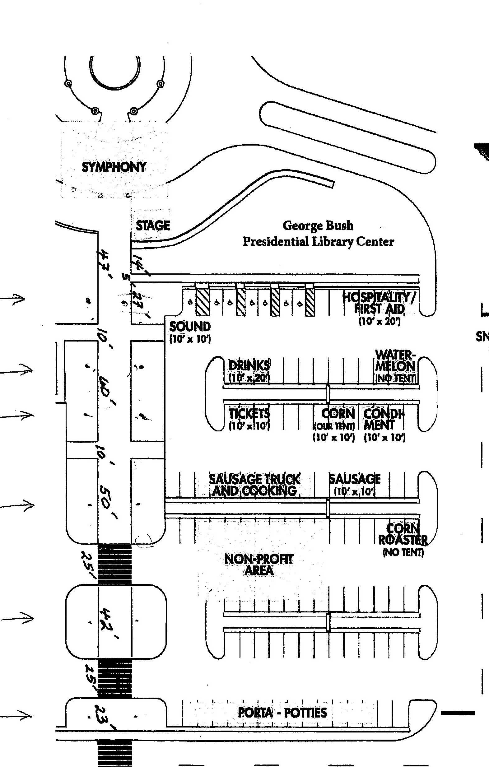

Plus two at the edges of the “flower” bed holding the huge main sign on George Bush Drive West.